****

**GOOGLE – HOW IT WORKS?**

Ever since, we first came across the World Wide Web, we have been wondering how the search engine works and how it displays the required search results at a lightning speed. First of all we Used to know, what a search engine is! I guess anyone can say that. It’s the world wide server which searches entire web and displays out the required results. It can be easily defined. But, there are many mechanism’s involving in it.

Many algorithms, programmes are designed to get the results instantly.

So, what are these phenomena? And what all algorithms involve in the GOOGLE search engine?

Let’s see what Larry page and Sergey brin explain about their simplified and efficient algorithm in this Article.

First of all let’s go to the history of the company.

Google first established their search engine in 1996 by **Larry page and Sergey brin**. They were College PH.D graduates at **Stanford University**. They want to step into the field of Web based search engines and make a stand in it. Their main Aim was to create a web based search engine which should Optimise and filter the relevant results with a great speed.

All their main idea was of Larry page .who proposed an Algorithm Called **‘Page’ Rank.**

**PAGE RANK ALGORITHM:-**

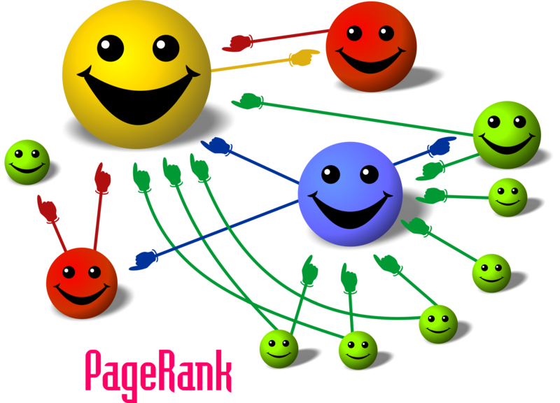

**Page rank is the numeric value of 1-10 assigned by the GOOGLE which defines a page more relevantly, how important it is in the World Wide Web**.

When one page is linked to another page, it effectively casts a vote for that page .Google uses this to find the most Voted page as their top search result. Page ranking is shortly called as PR.

**First of all let’s discuss some facts about page ranking.**

**\*Pages With higher PR appear top in the search engines.**

**\*PR is updated every week.**

**\*More the PageRank value. More the relevant is the page**

**\*According to Google .Page rank is equally distributed among the links of the web page.**

**\*Page ranking is generally a probability distribution of a person randomly clicking on links will arrive at any page**

Page rank requires many phases of iterations to find the exact page what we want.

First, let’s consider 4 Web pages A, B, C, D. These pages have many pages linked to it. Assume that there are no outgoing links from this page to other pages.

Firstly, Page rank is initialised same to all pages A, B, C, D. So the sum of the page ranks of all these 4 pages gives us the total number of webpages linked to these pages. Each page in this example has a page rank of 1.

As we all know that is the person clicking the webpage (probability) will be between 0 and 1.

Next, these pages have some outbound links. It means that, these pages have some linkage among them like, from **A->B and A->C or A->D, D->B etc.**

If the only links in the system were from pages **B**, **C**, and **D** to **A**, each link would transfer 0.25 probability of PageRank to **A** for a total of 0.75 in the 1st  iteration.

PR(A)= PR(B) + PR(C) + PR(D).\,

**PR (A) = 0.25 + 0.25 + 0.25 = 0.75**

**Outgoing linkages**

**0.25**

**0.25**

**0.25**

Suppose, Instead that page **B** had a link to pages **C** and **A**, while page **D** had links to all three pages. Thus, upon the next iteration, page **B** would transfer half of its existing value, or 0.125, to page **A** and the other half, or 0.125, to page **C**. Since **D** had three outbound links, it would transfer one third of its existing value, or approximately 0.083, to A.

**0.083**

**0.083**

**0.083**

**0.125**

**0.125**

This gives the formula as

PR(A)= \frac{PR(B)}{2}+ \frac{PR(C)}{1}+ \frac{PR(D)}{3}.\,

So, we can generalise this algorithm and formulate an equation. This looks like this.

**PR(A)= \frac{PR(B)}{L(B)}+ \frac{PR(C)}{L(C)}+ \frac{PR(D)}{L(D)}. \,**

PR (A), PR (B), PR (C), PR (D), Are the page ranks of the pages A, B, C, D.

L (A), L (B), L (C) Are the number of out bounding links among the pages.

**In the general case, the PageRank value for any page u can be expressed as:**

**PR(u) = \sum_{v \in B_u} \frac{PR(v)}{L(v)},**

So this defines the most simplified General algorithm for page ranking.

* **Vamshi reddy( 2nd year Computer science)**